|  |  |  |  |  |  |  |  |  |  |
| --- | --- | --- | --- | --- | --- | --- | --- | --- | --- |
| Adressincommand | J | ALU | A | B | OUT | MBR | PC | B select | com |
| 00001 | 0 | 000 | 0 | 0 | 0 | 1 | 0 | 00 | mbr=a |
| 00010 | 0 | 011 | 0 | 0 | 0 | 0 | 0 | 10 | &&&& |
| 00011 | 0 | 011 | 0 | 0 | 0 | 0 | 1 | 10 | pc=pc+1 |
| 00000 | 1 | 000 | 0 | 0 | 0 | 0 | 0 | 00 | jmp |
|  |  |  |  |  |  |  |  |  |  |
| 00000 | 1 | 001 | 1 | 0 | 0 | 0 | 0 | 11 | test |
| 00000 | 1 | 000 | 0 | 0 | 1 | 0 | 0 | 00 | test |
| 00000 | 1 | 010 | 1 | 0 | 0 | 0 | 0 | 00 | test |
| 00000 | 1 | 000 | 0 | 0 | 0 | 0 | 0 | 00 | test |
|  |  |  |  |  |  |  |  |  |  |
| 00000 | 0 | 000 | 0 | 0 | 0 | 0 | 0 | 00 | ! |
|  |  |  |  |  |  |  |  |  |  |
| 00001 | 0 | 000 | 0 | 0 | 0 | 0 | 1 | 00 | pc=a |
| 00010 | 0 | 001 | 0 | 0 | 0 | 1 | 0 | 10 | mbr=pc |
| 00000 | 1 | 000 | 0 | 0 | 0 | 0 | 0 | 00 | jmp |
| 00011 | 0 | 011 | 0 | 0 | 0 | 0 | 1 | 10 | pc=pc+1 |

Список разработанных команд

Схема CPU

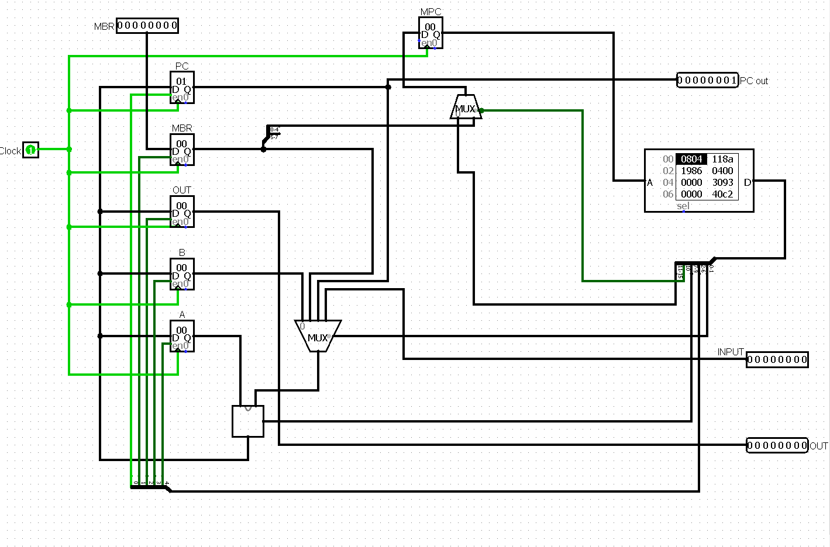

ROM

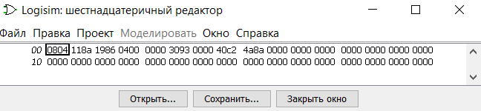

ROM

-----переключение на следующую команду в RAM

-----команда movinput, output

----- команда jmp 0

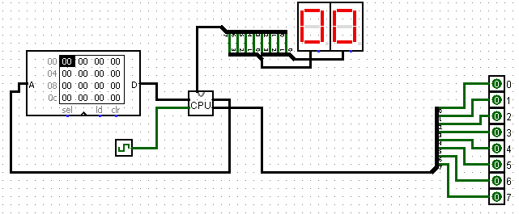

Спустя несколько тактов

